# **Inventory Management System Project in C++**

## 

## **What is an inventory management system project?**

Is an inventory management system that enables the user to easily manage and maintain their products in stock. The inventory store management system lets users add, change, and delete items, and do control on order processing.

## **Why Inventory Management is important?**

Small businesses need inventory management because it helps them manage many locations, avoid stock outs, and maintain correct records. Instead of trying to do them all by hand, an inventory system makes it easier to do these things.

## **Task And Features Available Inventory Management System C++**

* Product Management

1. Add Products to Stock & save Data to file
2. Display Current Stock
3. Search Item in Stock
4. Remove Item in Stock
5. Update Item in Stock
6. Sort Item

* Order Processing

1. Add Customer and Products Order
2. View Bills
3. Delete Customer Cancel Order
4. Update and Generate Bill(Can only Generate a Bill for one Item purchased)
5. Search order
6. Sort orders

* **Project Technology and Tools**

| **About Project** | **Project Details** |
| --- | --- |
| Project Name : | Inventory Management System Project in C++ |
| Project Platform : | C++ |
| Programming Language Used: | C++ Programming Language |
| Developer Name : | Yos Piseth |
| IDE Tool (Recommended): | Visual Studio Code |
| Project type: | CLI Desktop Application Software |
| Data Storage: | Store data in .dat file |
| Created date: | 18/12/2023 |
| Modified date: | 29/01/2024 |

* **Design UML Class Diagram**

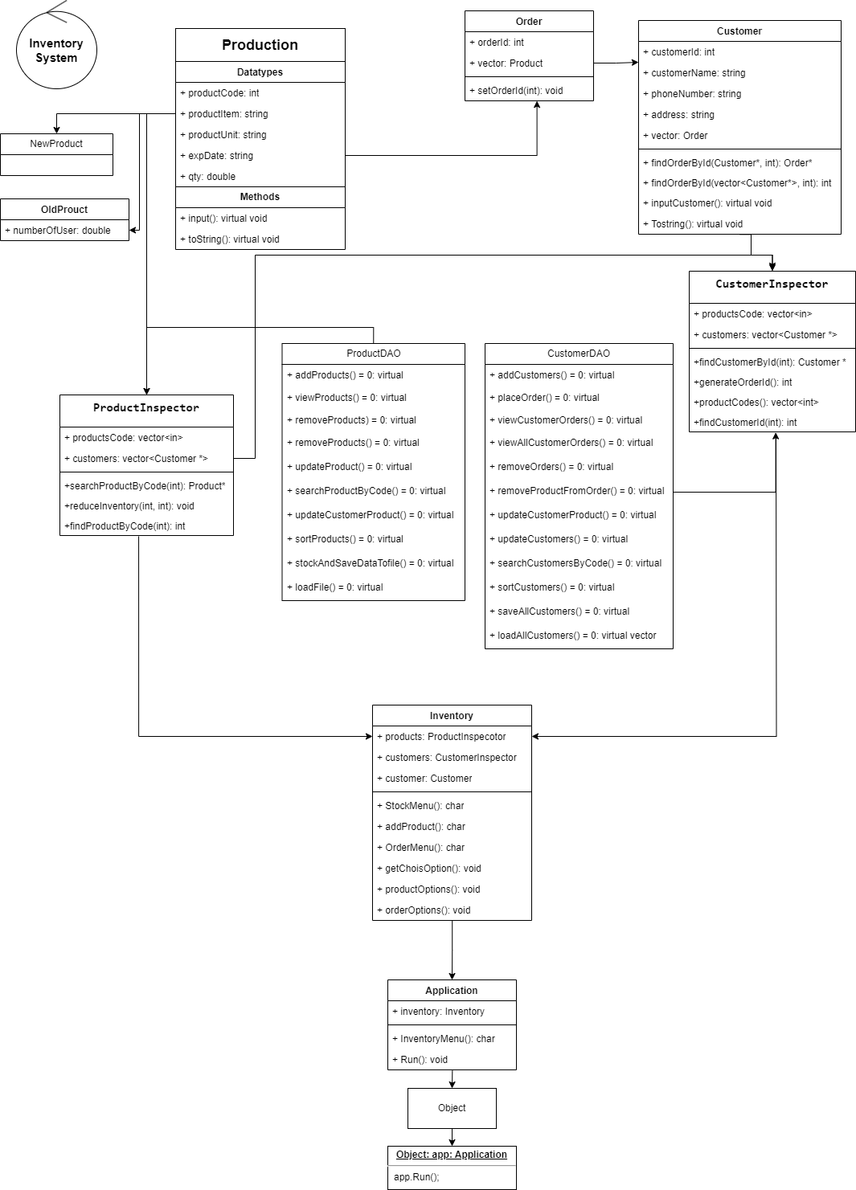

* **Design UI**
  + **Menu**

**============> Inventory System ⇐===========**

___________________________________________________

1. **Add Products to Stock & save Data to file**
2. **Display Current Stock**
3. **Search Item in Stock**
4. **Remove Item in Stock**
5. **Update Item in Stock**
6. **Sort Item**
7. **Exit Application**

___________________________________________________

**Choose Options:**

* **Add Products To Stock**

**============> Add Product To Stock ⇐===========**

**Enter Product Code: 1001**

**Enter Product Name: Vital Water**

**Enter Product Unit: 1.5L**

**Enter Expire Date: 01/12/2024**

**Enter Quantity: 1200**

**—-----------------------------------------------------------------**

**Add again or Leave[y/n]:**

* **Display Current Stock**

**============> Display Current Stock ⇐===========**

**Inventory**

**__________________________________________________________________**

**Code Name Unit Date Quantity**

**__________________________________________________________________**

**1001 Vital Water 1.5L 01/12/2024 1200**

**__________________________________________________________________**

**Add again or Leave[y/n]:**

* **Search Item in Stock**

**============> Inventory System ⇐===========**

**Search Item**

**__________________________________________________________________**

**Enter Product Code: 1001**

**Enter Product Name: Vital Water**

**Enter Product Unit: 1.5L**

**Enter Expire Date: 01/12/2024**

**Enter Quantity: 1200**

**—-----------------------------------------------------------------**

**Inventory**

**__________________________________________________________________**

**Code Name Unit Date Quantity**

**__________________________________________________________________**

**1001 Vital Water 1.5L 01/12/2024 1200**

**__________________________________________________________________**

**Search Again or Leave[y/n]:**

* **Remove Item in Stock**

**==========> Inventory System ⇐===========**

**Remove Item**

**__________________________________________________________________**

**Enter Product Code: 1001**

**Enter Product Name: Vital Water**

**Enter Product Unit: 1.5L**

**Enter Expire Date: 01/12/2024**

**Enter Quantity: 1200**

**—-----------------------------------------------------------------**

**Inventory**

**__________________________________________________________________**

**Code Name Unit Date Quantity**

**__________________________________________________________________**

**__________________________________________________________________**

**Press [y] to Leave:**